Partner and Changemaker,
Our goal is to change health in West Virginia for the better—but we can’t do it without your help. I/We [Organization Name] am/are contacting you to ask for your help in promoting Mountain State Assessment of Trends in Community Health (MATCH). The MATCH is a survey, similar to the US census, designed to collect important health information specific to West Virginians.
One in 14 West Virginians will be selected to complete the MATCH. Each selected West Virginian will have three options to take the survey—online, paper, or phone. Those who complete the survey will be compensated for their time.
By completing the MATCH, you ensure that your voice and the voice of your community is heard. Your feedback makes a true difference, like helping policy makers and health officials better understand the reality of health in your community and providing the information needed to improve access to the health services you need. West Virginians should never have to miss doctor appointments or suffer through injuries without proper healthcare! Support us in improving the health of your community - tell your friends and neighbors why completing the MATCH matters!
For additional information, please visit WVMATCHSurvey.org or contact the MATCH team at 304-581-1928 or WVMATCHSurvey@hsc.wvu.edu

Thank you,
[Your name]

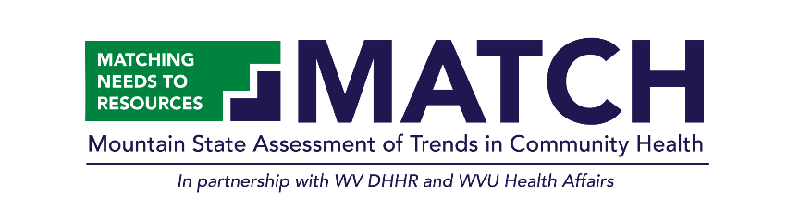
The MATCH team

