Dear Partner and Changemaker,
Thank you for agreeing to help promote the Mountain State Assessment of Trends in Community Health (MATCH)! Our goal is to change health in West Virginia for the better—but we can’t do it without your help. In order to accomplish this goal, we need everyone who is invited to take the MATCH survey to complete it. The survey information is critical to help match community health needs to available resources, and to better allocate state health resources to the WV communities most in need.
For your convenience, the MATCH project team has drafted a PowerPoint presentation to help facilitate discussions about the survey, a listserv message, a promotional flyer and talking points to help you spread the word.
The listserv message below can be copied and pasted into your own template. Additionally, please feel free to add your own touches and language to the provided materials, as you know what is most important to your audiences.
Please do not hesitate to reach out to the MATCH team at WVMATCHsurvey@hsc.wvu.edu should you have questions, concerns, or ideas to share.

Thank you,
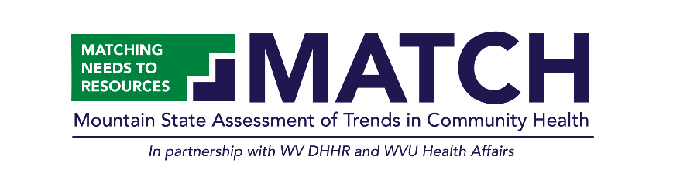
[Your signature]

Listserv Sample

Calling on all community partners!
Our goal is to change health in West Virginia for the better—but we can’t do it without your help. The Mountain State Assessment of Trends in Community Health (MATCH) is a new West Virginia survey that will collect critical health information from West Virginians across all WV counties, starting August 2021 through January 2022.
The goal of MATCH is to better understand the health of West Virginians, so that health needs can be better matched with community health resources.
One in 14 West Virginians will be selected to participate in the survey. If selected, you will receive an invitation with a choice on how you would like to complete the survey — either online, by mail, or by phone. West Virginians who complete the survey will be compensated for their time.
Each resident who participates in the MATCH survey acts as a community advocate—helping to inform decisions that have a true impact on the everyday health and well-being of West Virginians.
By completing the MATCH survey, you ensure that your voice is heard. Your feedback makes a true difference, like preventing cuts to healthcare funding and providing better access to the services you need. West Virginians should never have to miss doctor appointments or suffer through injuries without proper healthcare. Support us in improving the health of your community! And tell your friends and neighbors why MATCH matters!
The survey will begin collecting information in August 2021!
Survey findings will be available in the summer of 2022. Individuals and organizations may access the data using a free online web query tool. Additionally, summary and analysis reports will be published and available on WVMATCHSurvey.org and formal data requests can be submitted to WVMATCHSurvey@hsc.wvu.edu.
For additional information, please visit WVMATCHSurvey.org or contact the MATCH team at 304-581-1928 or WVMATCHSurvey@hsc.wvu.edu.

Please help us spread the word and help create healthier communities!

Talking points to add to a separate document:
A new biennial West Virginia population-based health survey—the Mountain State Assessment of Trends in Community Health (MATCH)—will gather information to help health officials and policy makers better understand the critical health needs of all 55 West Virginia counties, with the goal of directing resources to communities that need them most.
The MATCH is a partnership between the West Virginia Department of Health and Human Resources and West Virginia University Office of Health Affairs.
Your participation can help provide data for our state leaders to make the best decisions possible about programs and policies. It can help with funding proposals and programs in your community and throughout our state.
Here’s a brief MATCH overview:
- Survey Period: August 2021 – January 2022
- Participants are chosen at random using a large database of WV residential addresses.
- If selected to participate, you will receive an invitation with a choice of how you would like to complete the survey – either online, by mail, or by phone.
- Information collected from the survey will be available to health departments, non-profit organizations, and other leaders. These groups can use this information to ensure that resources are targeted to the areas of WV that need it most.
- Survey findings will be available in the summer of 2022. Individuals and organizations may access the data using a free online web query tool. Additionally, summary and analysis reports will be published and available on WVMATCHSurvey.org and formal data requests can be submitted to WVMATCHSurvey@hsc.wvu.edu.

